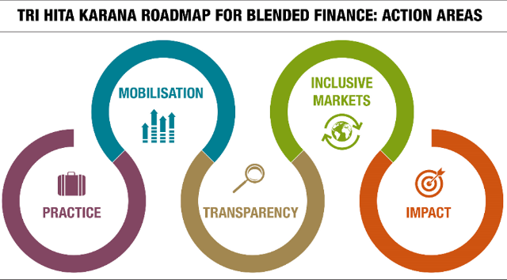

**Tri Hita Karana Statement**

on

**The Role of DFIs[1] and shareholders in**

**building back better in the wake of Covid-19[2]**

8 October 2020

**Recognizing the magnitude of the Covid-19 pandemic and its impact on developing countries, there is** **a critical need to address both the immediate health emergency and the longer-term socio-economic consequences that developing countries will face in the protracted crisis**, in particular poorer and more vulnerable ones. The challenge is three-pronged, impacting the core of health systems, economies and societies across the world. While spending needs are massive and urgent, fiscal space is tightly constrained, particularly amongst the Least-Developed Countries (LDCs), who are unable to match developed countries’ economic stimulus packages.

**The Covid-19 crisis risks creating major setbacks in financing for sustainable development and compromise our ability to reach the SDGs**. Altogether, while Official Development Assistance (ODA) and international aid policies can assist in the short term, a robust private sector is a fundamental engine of economic growth and poverty reduction. In particular, micro, small, and medium sized enterprises (MSMEs), which play a central role in developing economies, both as engines of growth and in terms of job creation potential, have been severely hit by the crisis. Many MSMEs face significant liquidity crises, which are turning into solvency crises.

**Development Finance Institutions (DFIs) have been major actors in the response to the crisis and have an opportunity to play in building back better in the wake of Covid-19.** DFIs have reacted promptly to the crisis, speedily adjusting and reallocating their portfolio, fast-tracking and simplifying their procedures to respond to the emergency situation. They are supporting their existing clients and reaching out to new clients to the maximum extent practicable.

**DFIs have a central role to play to provide countercyclical support both in the short term and for the sustainable recovery, which needs to be prepared now.** They need to leverage more and better finance at scale, for greater impact, in the context of higher risk and uncertainty generated by the Covid-19 crisis. The challenge for donor governments as shareholders of DFIs is to identify best ways to support DFIs’ historic challenges in being more countercyclical in helping to build back better, and, more broadly, to enable them to better meet the expectations of the stakeholders and beneficiaries that depend on them.

**Key recommendations for DFIs and shareholders** to best speed up a sustainable and resilient recovery in developing economies, provide countercyclical finance to the most vulnerable and meet their development mandates are as follows:

Adopt measures and processes allowing DFIs to respond to the protracted Covid-19 crisis in a more **countercyclical, sustainable and impactful** way, tackling the gender and inequality dimensions of the recovery;

**Undertake activities in riskier, more fragile, and low income environments** targeted at actors and countries more severely hit by the crisis, by a combination of financing mechanisms as appropriate to each institution, such as accepting lower risk-adjusted returns, stretching balance sheets, and benefiting from enhanced guarantee mechanisms or capital increase, and when appropriate with the support of blended concessional finance;

**Increase support and exposure to private sector and in particular MSMEs**, with a focus on sustainability, gender and building resilience (without compromising on other types of financing);

**Focus even more on building stronger and innovative local partnerships**, including with national and regional development banks, emerging market sponsors, local financiers, etc.;

* **Enhance the capacity for innovation to build project pipelines**, in synergy with local actors and donors, partnering with other DFIs, that work in LICs and serve poor and vulnerable populations;

**Concentrate efforts on the systemic effects of interventions on the recovery**, beyond the immediate impact of single transactions, building back better, including by contributing to improve the investment climate in developing economies and to preserve gains already achieved prior, e.g. jobs;

**Pursue opportunities for syndication, risk-sharing mechanisms, alliances and cooperation with other DFIs and development financiers**. This may include, as appropriate to individual institutions or groups of institutions, special purpose vehicles and financial structures to be added to the DFI toolkit, which would contribute to stretch DFI capital, take risk off-balance-sheet, make more projects bankable, and facilitate investment, in particular to address at scale the critical situation of MSMEs and firms in LICs. As one option, shareholders could consider allocating additional risk-tolerant capital to an MSME Covid-19 facility that would help interested DFIs manage more risk and mobilize more private finance through use of subordinated instruments like guarantees and equity. This could be done by leveraging and expanding existing facilities that have the right capabilities, and when appropriate with the support of blended concessional finance;

**Focus on opportunities that a more efficient and expanded use of blended finance, including with concessional support, can bring**, notably to mobilise sustainable private finance at scale for greater sustainable and transformative impact.

1. DFIs in this Statement include members of the European Development Finance Institutions (EDFI) as well as members of the DFI Working Group on Blended Concessional Finance for Private Sector Projects (which comprises a range of Multilateral Development Banks and Regional Development Banks such as IFC, AfDB, EBRD, EIB, IDB apart from EDFI members).
2. Reference to the THK report on Covid-19 and blended finance for more information on the background for the Statement.